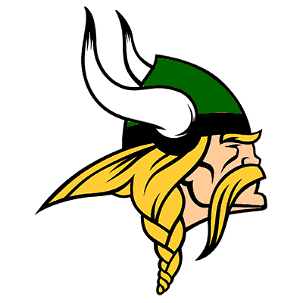

NORTHLAND HIGH SCHOOL
2024 VIKINGS CROSS COUNTRY
SCHEDULE

GAME DATE OPPONENT TIME RESULTS
1 August 24th @ Whitehall HS 9:30am _______
2 August 28th @ Africentric EC (Eastmoor) 4:30pm _______
3 August 31st @ Westerville North HS 9:00am _______
4 September 4th @ South HS 9:30am _______
5 September 11th @ Africentric EC (Eastmoor) 4:30pm _______
6 September 14th @ Newark HS 9:00am _______
7 September 18th @ Whetstone HS 4:30pm _______
8 September 21st @ Lancaster HS 9:00am _______
9 September 25th @ Africentric EC (Eastmoor) 4:30pm _______
10 September 28th @ Africentric EC 10:00am _______
11 October 2nd @ South HS 4:30pm _______

2024 Vikings Coaching Staff:
Boys Head Coach: Joe Johnson Girls Head Coach: Hank Cornley
Principal: Jason Johnson
Athletic Director: Mario Bowles
Athletic Trainer: Kasey Wentzel

